Practical realization of adjustable signal generator using analog devices
DO NOT DELETE THIS LINE (PRESS PARAGRAPH MARKS (¶) TO SEE THIS LINE)

Petar Nikolić
Dept. of Microelectronics
Faculty of Electronic Engineering
Niš, Serbia
nikolicpetar@elfak.rs N/A
DO NOT DELETE THIS LINE (PRESS PARAGRAPH MARKS (¶) TO SEE THIS LINE)

Abstract— This project shows the realization of a signal generator using NE555, LM2902 quad-operational amplifier and RC low pass filters. Generated frequency range for this signal generator is 50 Hz to 4 kHz. Duty cycle of the square signal and of symmetry of the triangle signal is in range of 0.9% to 99.1%. Amplitude range and added offset both depend on the supply voltage of the circuit.
Keywords—multivibrator, filter, modification, amplitude, frequency

Introduction
Modern signal generator devices are high in price and are not available to everyone, and for some applications, buying such a costly device is not the best option. So the aim of this paper is to show how, by using elementary integrated circuits and passive components, a signal generator can be constructed.
This signal generator circuit consists of 3 blocks that are used to generate and modify the signals. First, a NE555 [1] oscillator generates a square and a triangle wave, then a square wave can be converted to a sine wave using RC filters. Sawtooth and impulse signals can also be generated.
By manually short-circuiting, the desired waveform can be shown on the output. Signal parameters are modified by the use of potentiometers. A practically realised circuit of this signal generator is shown in Fig. 1. This circuit was simulated in LTspice simulator.
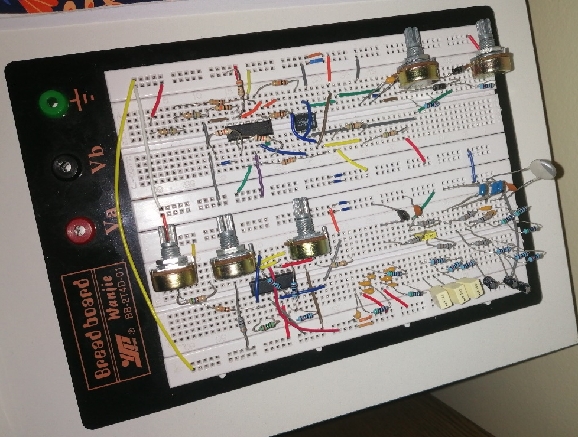
- Signal generator circuit realised on a breadboard.

Description of function of signal generator blocks

Oscillator block
In this block the base square waveform is generated using NE555 in astable multivibrator configuration. The 1N4001 [2] diodes are used so that the capacitor is charged and dicharged through a different potentiometer and resistor pair. This enables the manual control of duty cycle of the square wave and the symmetry for a triangular waveform by changing the value of potentiometers.
Trigger and threshold pins of NE555 are short-circuited and connected to the positive electrode of the capacitor, and with NE555’s internal structure in mind, this means that the capacitor charges to 2/3 * ,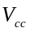and when the voltage across the capacitor exceeds this value, that triggers the comparator and the SR latch is reset, which enables the capacitor to discharge to 1/3 * ., and the cycle starts again [3].
The charging time of the capacitor is 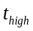 for the square wave, and discharging time is 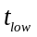. Oscillator block is shown in Fig. 2. The voltage on the capacitor and ouput of NE555 is shown on Fig. 3.
The resistors that are in series with potentiometers have a function to limit the diode current, in case the potentiometers are set at their lowest resistance value. The capacitor value is 68 nF and the resistance in series with it is in range from 2 kΩ to 222 kΩ for each resistor-potentiometer pair, and with those values the frequency range is calculated with (1):
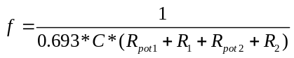 (1)
In the LTspice simulator [4] this frequency can vary from 5 Hz to 20 kHz, depending on the capacitor value, because at 20 kHz great distortions are present in the generated waveform. However, when this schematic is realised with real components, the frequency range is narrower, due to the parasitic values that are present. For a 68 nF capacitor frequency range goes from 50 Hz to 5.3 kHz, but because of the parasitic values that cause distortions at 4 kHz, real frequency range goes from 50 Hz to 4 kHz. The duty cycle and symmetry have a range going from 0.9% to 99.1%. Duty cycle/symmetry formula is shown in (2):
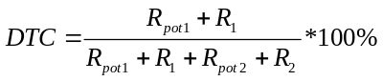 (2)
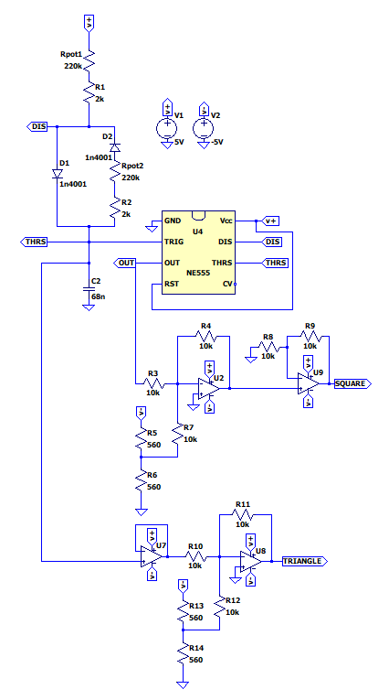
- Oscillator block (NE555 square/triangle wave oscillator).
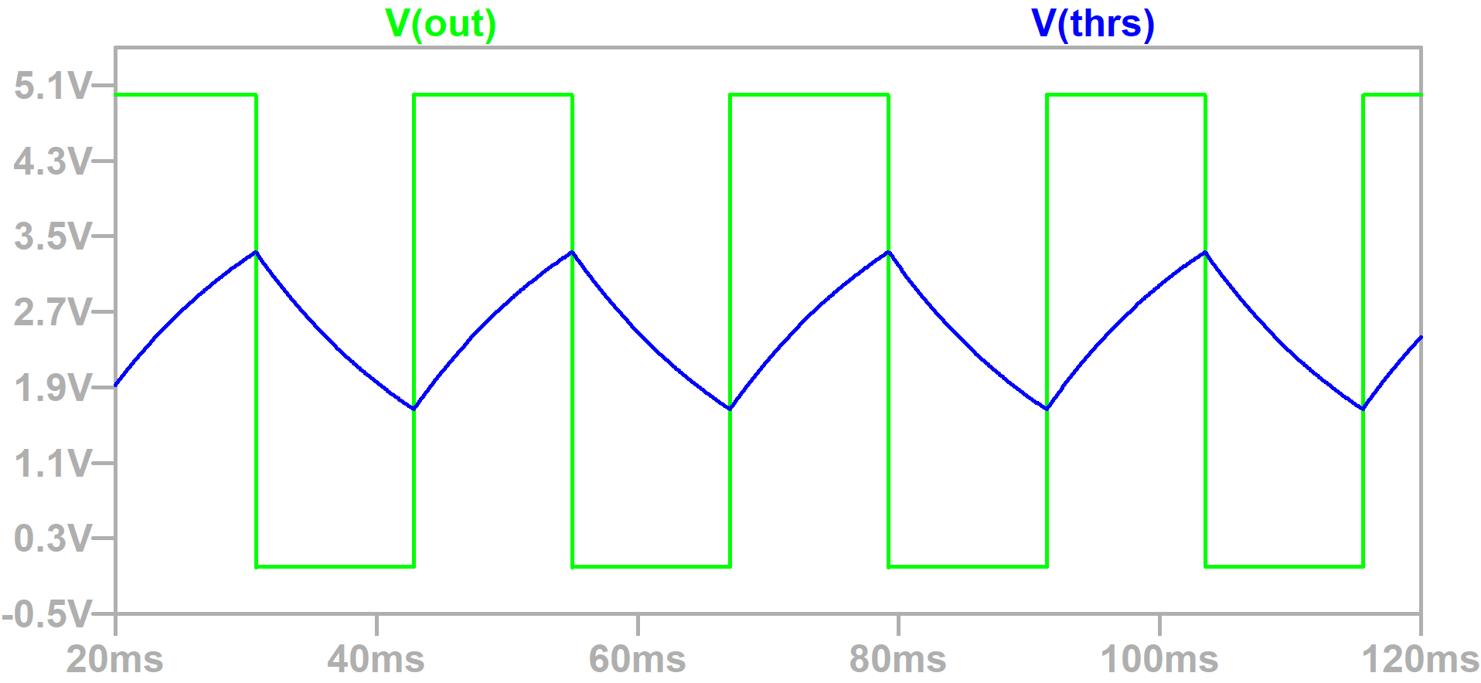
- Charging and disharging of the capacitor and square wave on the output of NE555.
The output pin of NE555 generates the square wave, but it’s amplitude has a range that goes from 0 V to the value of , because NE555 is single-supply. So LM2902 [5] dual-supply circuit is applied to change that range to - to . With the first operational amplifier in inverting configuration, half of - is added to the output signal of NE555. Then the square wave on the output of this operational amplifier has an amplitude range going from
-1/2 * to +1/2 * . This square wave is passed to the non-inverting pin of the next op-amp which further amplifies the signal by A = 2. So the final amplitude range for square wave is - to .
Triangular waveform is present on the positive electrode of the capacitor, it’s shape presents the charging and discharging of the capacitor. This signal is passed to the input of voltage-buffer circuit, so that the next circuits don’t affect the NE555. In the next step, offset of -1/2 * is added to the signal. Final amplitude range for the triangular waveform is -1/6 * to +1/6 * .
These amplitude ranges are of fixed values on the output of the first block, but they can be modified when passed, by short-circuiting, to the third block, which function is to modify the amplitude and add an offset to the generated signal.
It is important to notice that square and triangular waveforms are both inverted once in this block. This is annuled with the summing amplifier circuit at the end of the third block.

Low pass filters block
This block contains the low-pass RC filter circuits which are the foundation for the forming of sinusoidal waveform. As input for these circuits, the square waveform generated in the previous block is being used. Depending on the frequency of the input signal, values of resistance and capacitance differ, so for the range from 50 Hz to 4 kHz, four different RC circuits are made. Each of these circuits have three low-pass filters that form the sinusoidal wave on the output [3]. The second block is shown in Fig. 4.
The range of frequencies for each RC circuit are experimentally confirmed to be 1.5 *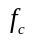 to 4.25 * , where is the corner-frequency of the base RC circuit. Formula for the corner-frequency is (3):
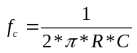 (3)
So for the first circuit 10 kΩ resistors and 680 nF capacitors are used to get the frequency range of 35 Hz to 100 Hz. The other three RC circuits have frequency ranges of: 200 Hz to 1 kHz, 1 kHz to 3.5 kHz and 3.5 kHz to 4 kHz.

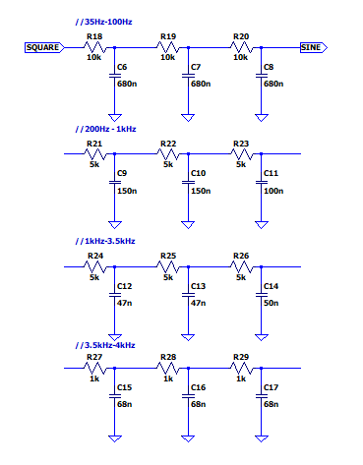
- RC filters used for the sine wave.
Some approximations have been made when calculating these ranges.
As the frequency of the input square wave increases, the amplitude of sinusoidal wave decreases.
In conclusion, this block is being used only when the sinusoidal waveform is generated, for all the other waveforms, first block and the third block are the only ones being used.

Signal modification block
Another LM2902 circuit is used in this block. As stated before, this block is used for signal modifications. By short-circuiting the waveform from previous blocks (square, triangular, sinusoidal, impulse, sawtooth or PWM), amplitude can be amplified or attenuated and positive or negative offset can be added to the waveform [6]. Third block is shown in Fig. 5.
At first signal is passed to a voltage divider which has a function to attenuate the signal, this is mostly used for the square/impulse/PWM signals because of their starting amplitude range of - to . For all the other signals starting amplitude range is lower. This voltage divider consists of a 560 Ω resistor and a 10 kΩ potentiometer.
This signal is amplified in the next step, op-amp in non-inverting configuration is used, with a 10 kΩ potentiometer as a feedback resistor, and a 1 kΩ resistor

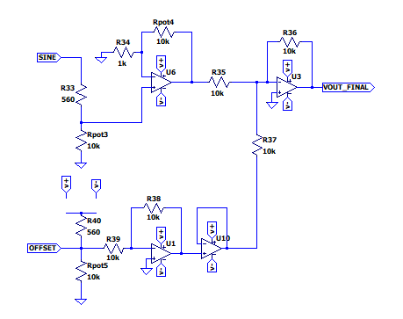
- Third block for signal modification.
with one pin connected to inverting input and the other connected to the ground. This means that the amplification is in the range from 0 to 11.
To modify the offset value another voltage divider is used, identical to the one used for attenuation of the input waveform, with - to chosen by short-circuiting. This offset is inverted once with an op-amp in inverting configuration. Then the signal is passed to a voltage-buffer for isolation of this circuit from the next one.
Amplified waveform signal and inverted offset signal are then passed to summing amplifier circuit which amplifies both of the signals by A = -1, so the sum of these voltages is present on the output. And the negative unity gain is used because both of the signals were inverted once, before being passed to this final circuit.
With all of the above taken into consideration, formulas for the offset and amplitude of the signal are, respectively, shown in (4) and (5):
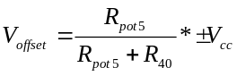 (4)
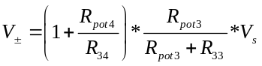 (5)
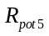- potentiometer used for offset value modification (0 -10 kΩ);
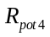 - potentiometer used for amplitude amplification (0 -10 kΩ);
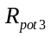 - potentiometer used for amplitude attenuation (0 -10 kΩ);
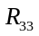, 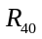 = 560 Ω, 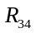 = 1 kΩ;
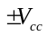- supply voltage;
- amplitude of the waveform on input of the third block.

Practical realization
In this chapter, signals that are being compared are results of LTspice simulation and real signals that have been recorded on an oscilloscope.
First, we can compare the square signal at its lowest possible frequency. At the lowest frequency of 50 Hz, potentiometers in the first block are both set to 210 kΩ, close to their maximum value. Supply voltage is ±10 V. The signal from LTspice simulation and signal recorded on the oscilloscope, are displayed in Fig. 6 and 7, respectively. By comparing these signals, it can be seen that there are no significant differences at 50 Hz, except that the amplitude of the signal on the oscilloscope is slightly below 10 V.
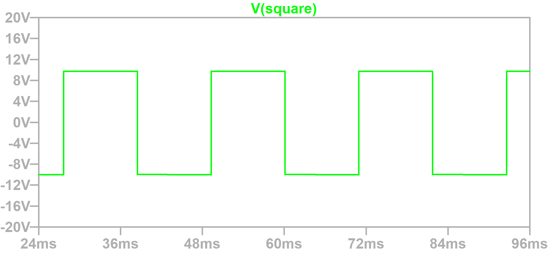
- LTspice simulation for 50 Hz square wave.
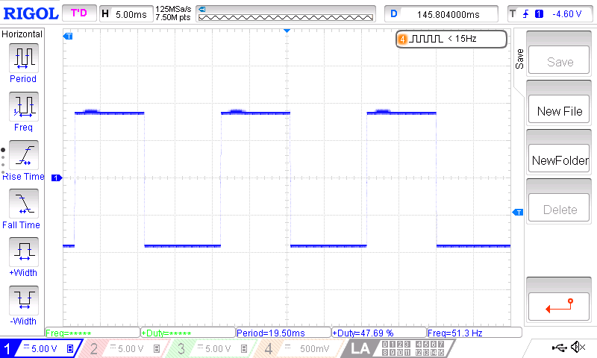
- 50Hz square signal recorded on the oscilloscope.
For the second comparison, a 4 kHz square wave is generated. Potentiometers in the first block are set to 650 Ω, close to their lowest value. Signals are displayed in Fig. 8 and in Fig. 9. On the signal from the oscilloscope we can see that there are distortions present due to the parasitic values of the wiring on the breadboard, so higher frequencies than 4 kHz can’t be generated.

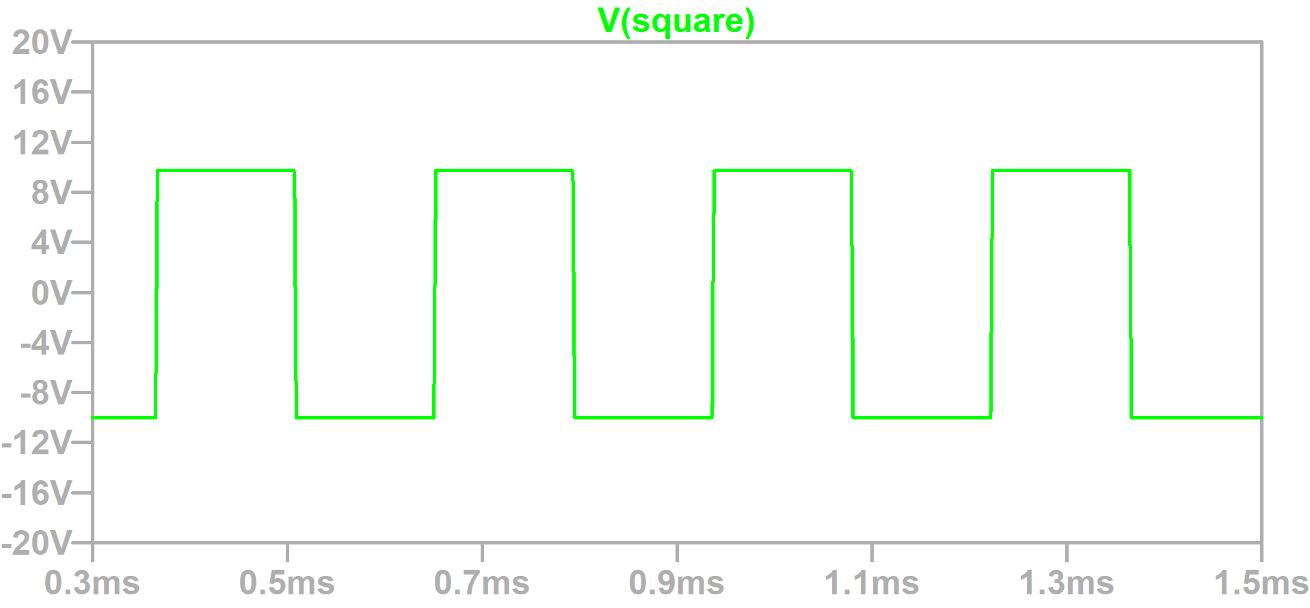
- LTspice simulation for 4kHz square wave.
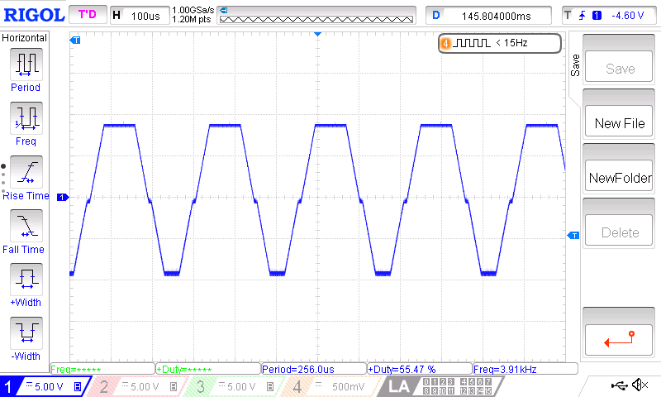
- 4kHz square signal recorded on the oscilloscope.
In Fig. 10. and Fig. 11. square, triangular and sine waves are shown, with the frequency set to 300 Hz for all three signals. Sine wave is amplified in the third block and, only on the oscilloscope screen, it is streched out for better viewing. This shows that within the given range of 50 Hz to 4 kHz, signals are generated without distortions.
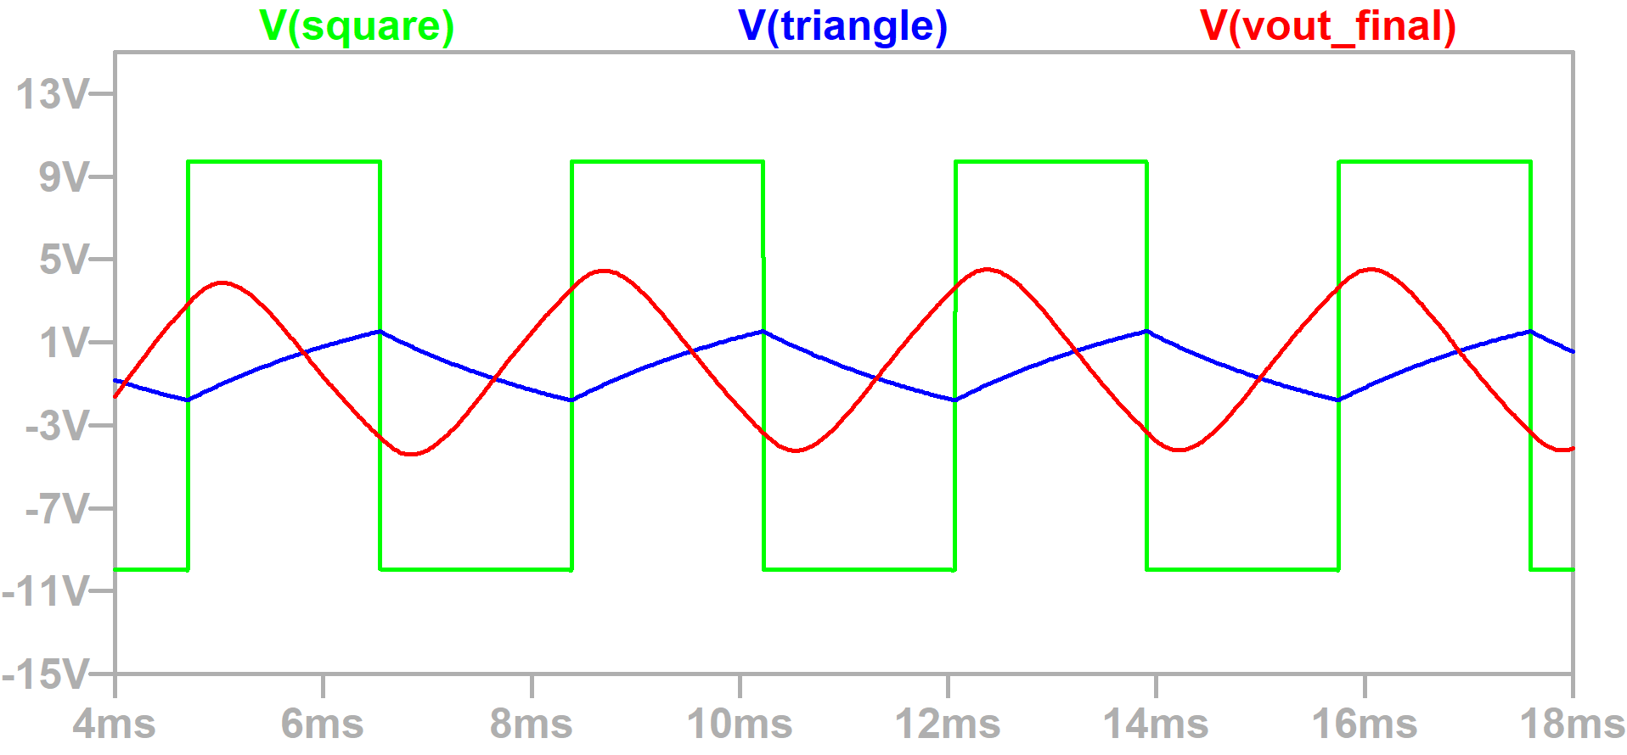
- LTspice simulation for 300 Hz square, triangle and sine wave.
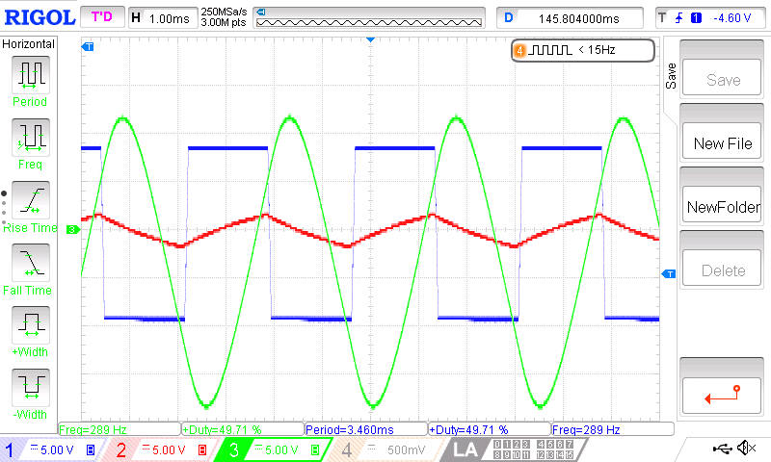
- 300 Hz square, triangle and sine signals recorded on the oscilloscope.
To see how signal parameters can be changed a sine wave is observed, with a frequency of 330 Hz, supply voltage is ±5 V. So signals in Fig. 12. and 13. are on the output of the second RC filter (200 Hz – 1 kHz). In LTspice amplitude is in range from 0.7 V to -0.8 V, and on the oscilloscope it is 0.4 V to -0.8 V.
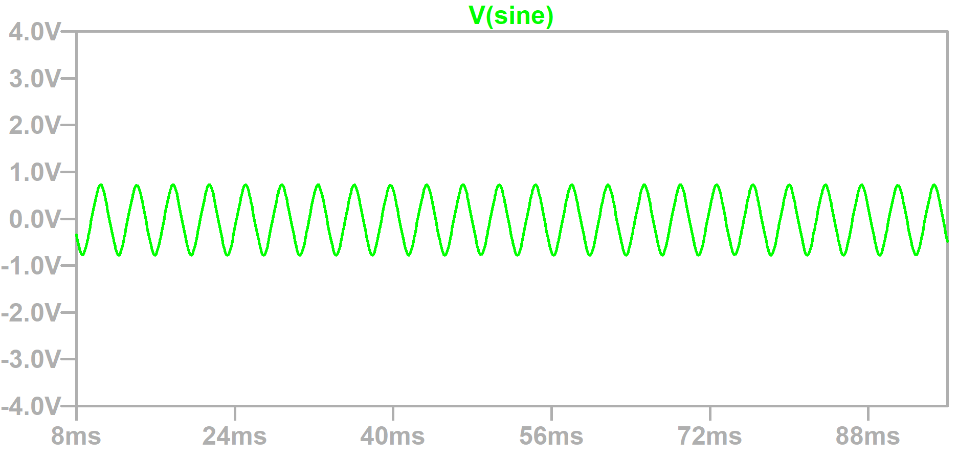
- LTspice simulation for 330 Hz unmodified sine wave.
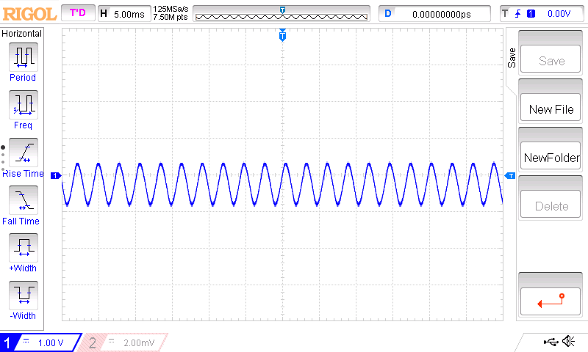
- 330 Hz unmodified sine signal recorded on the oscilloscope.
In Fig. 14. and 15. sine wave is amplified to it’s maximum possible amplitude range. On the oscilloscope amplitude range is -4 V to 4 V, and -4.6 V to 5 V in the simulation.

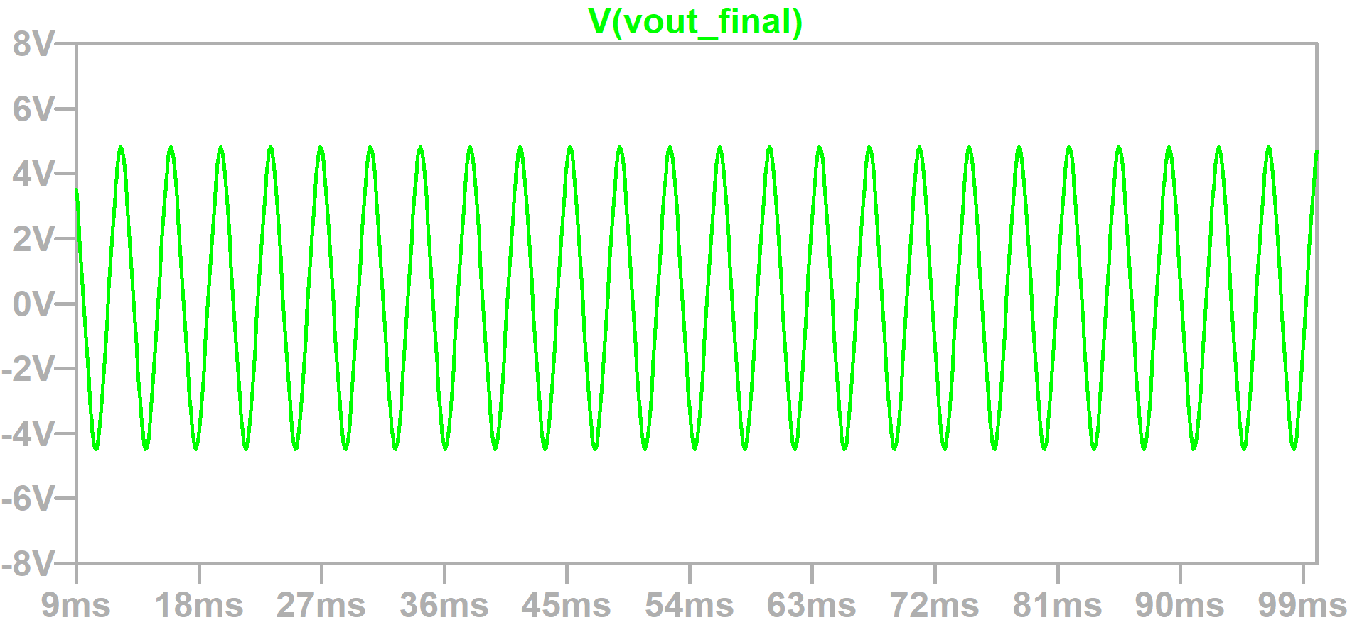
- LTspice simulation for 330 Hz amplified sine wave.
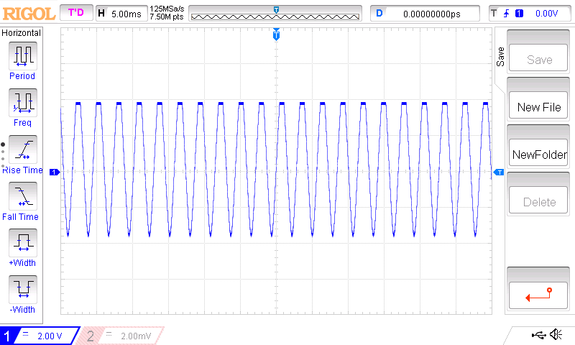

- 330 Hz amplified sine signal recorded on the oscilloscope.
In the last comparison, in Figs. 16. and 17, an offset of +2 V is added to the amplified sine signal. It is amplified by 4 in this case. On the oscilloscope amplitude range is 0 V to 4 V, and in LTspice it is -0.7 V to 5 V.
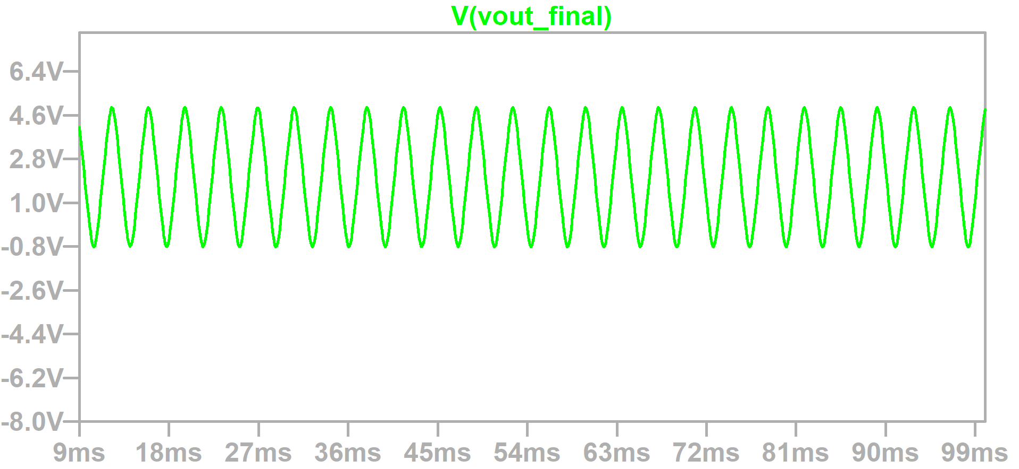
- LTspice simulation for 330 Hz sine wave with an offset.
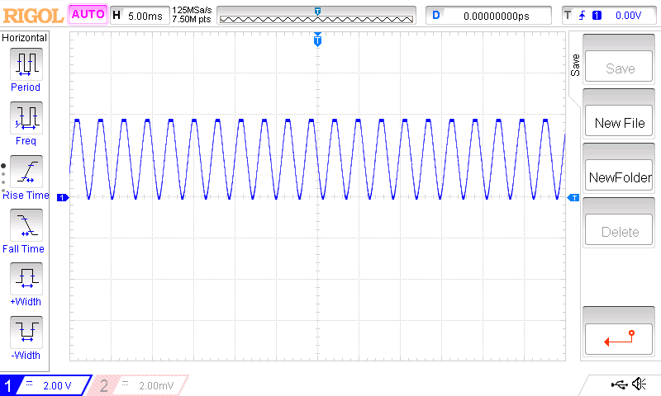
- 330 Hz sine signal with an offset recorded on the oscilloscope.

Conclussion
In conclussion, this method for a signal generator has it’s advantages and disadvantages. Simple design and solid wave shape within the given range of frequencies are it’s advantage. It’s disadvantage is manual control of the generator by short-circuiting the correct parts of the circuit. So, for further upgrades, this problem could be solved by implementing a circuit with electrical switches (MOSFETs) and a microcontroller which would control those switches through a user defined program.

Acknowlegment
The author thanks m. eng. Nikola Mitrović for the practical help and suggestions in the making of this paper.

References
- NE555 datasheet. Available at: https://www.diodes.com/assets/Datasheets/NE555_SA555_NA555.pdf
- 1N4001 datasheet. Available at: https://www.vishay.com/docs/88503/1n4001.pdf
- Z. Prijić, Analog microelectronics, lectures. Available at: https://mikro.elfak.ni.ac.rs/predmeti/analogna-mikroelektronika/analogna-mikroelektronika-literatura/
- LTspice simulator. Available at: https://www.analog.com/en/resources/design-tools-and-calculators/ltspice-simulator.html
- LM2902 datasheet. Available at: https://www.st.com/resource/en/datasheet/lm2902.pdf
- N. Mitrović, D. Danković, Z. Prijić, “Laboratorijski praktikum sa zadacima za samostalan rad iz predmeta analogna mikroelektronika”, Faculty of Electronic Engineering, Niš, 2022.

